Unearthing the Environmental Impact of Human Activity: A Global CO2 Emission Analysis

INTRODUCTION
Carbon dioxide (CO₂) i s a naturally occurring colorless and odorless gas. It has a boiling point of −70 °C (sublimes), vapor density of 1.53, and is slightly soluble in water. The atmospheric concentration in preindustrial times was 0.028% and in May 2013 was 0.04% recorded at Mauna Loa, Hawaii, USA. It is essential for the survival of most living organisms and cycles in the ecosystem, through respiration (aerobic and anaerobic), photosynthesis, and combustion. Carbon dioxide plays an important role in the regulation of earth's temperature, and is one of the greenhouse gases.

PURPOSE OF THIS PROJECT
Globally, some 230 million tonnes (Mt) of carbon dioxide (CO2) are used every year. The largest consumer is the fertiliser industry, where 130 Mt CO₂ is used in urea manufacturing, followed by oil and gas, with a consumption of 70 to 80 Mt CO₂ for enhanced oil recovery. Other commercial applications include food and beverage production, metal fabrication, cooling, fire suppression and stimulating plant growth in greenhouses. Most commercial applications today involve direct use of CO₂.
New pathways involve transforming CO2 into fuels, chemicals and building materials. These chemical and biological conversion processes are attracting increasing interest from governments, industry and investors, but most are still in their infancy and face commercial and regulatory challenges.

EMPATHY MAP & BRAINSTORMING MAP

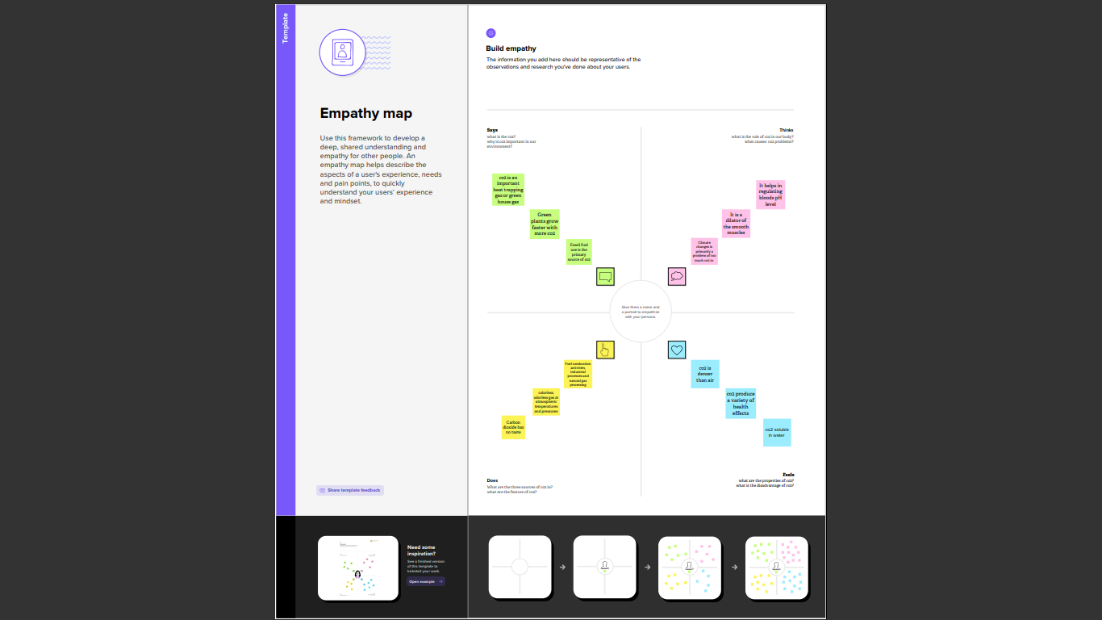

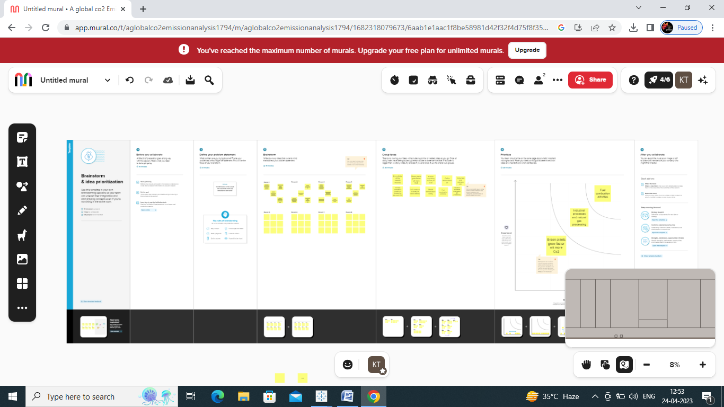

RESULT

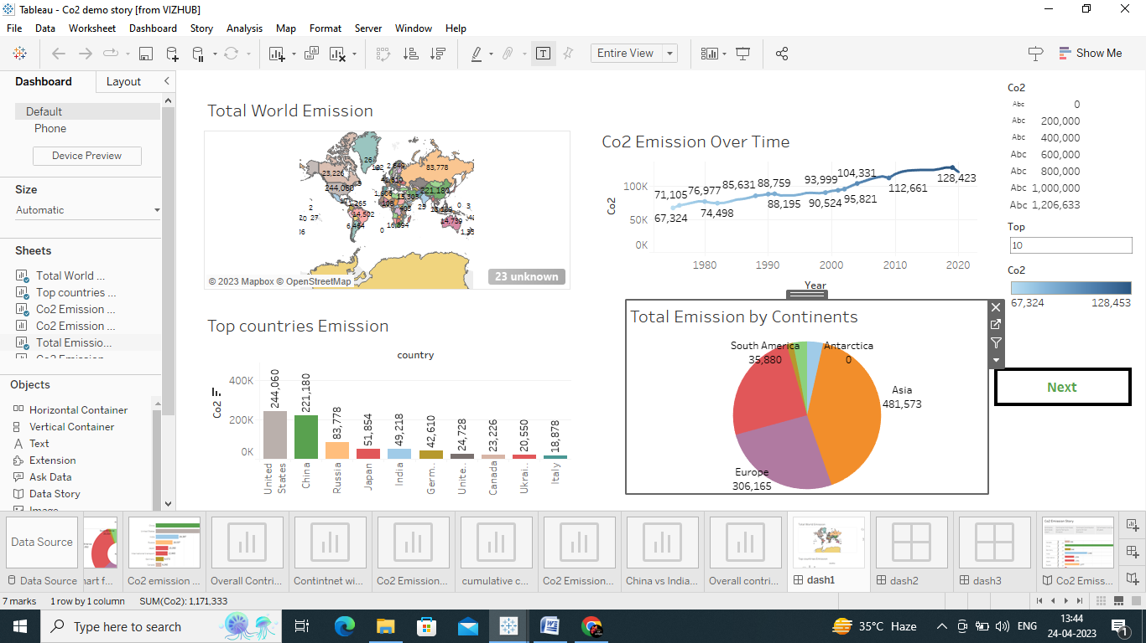
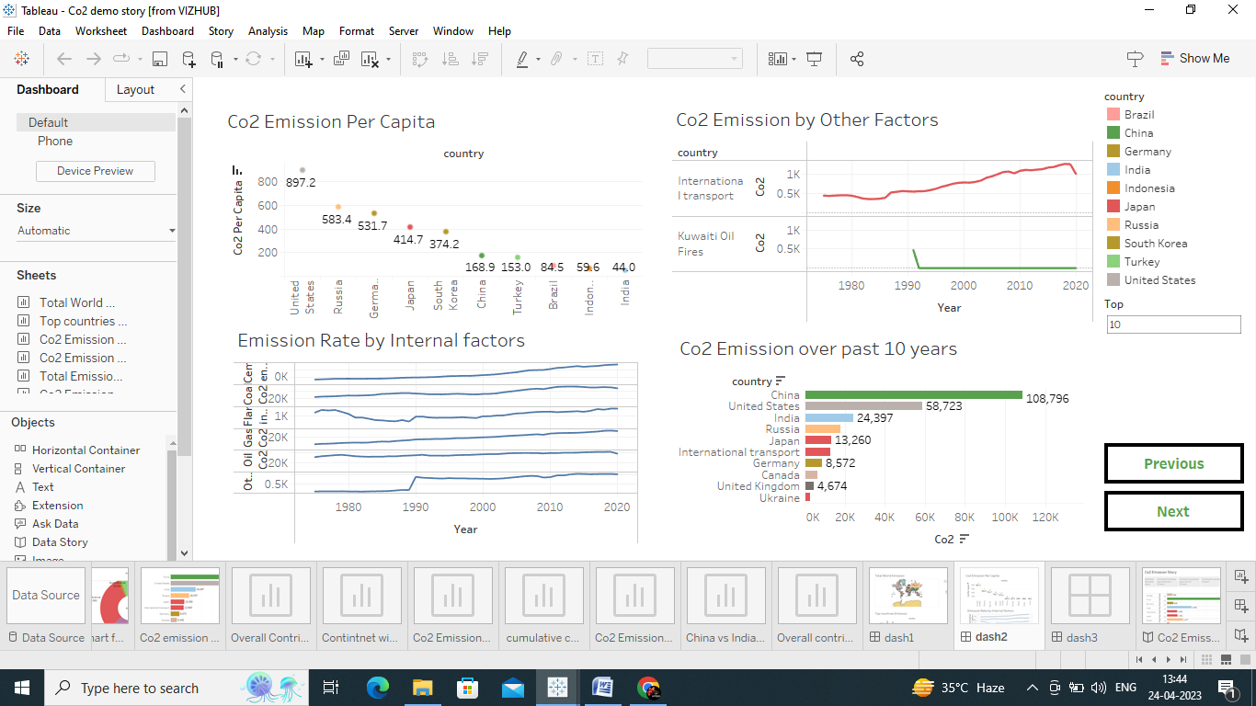
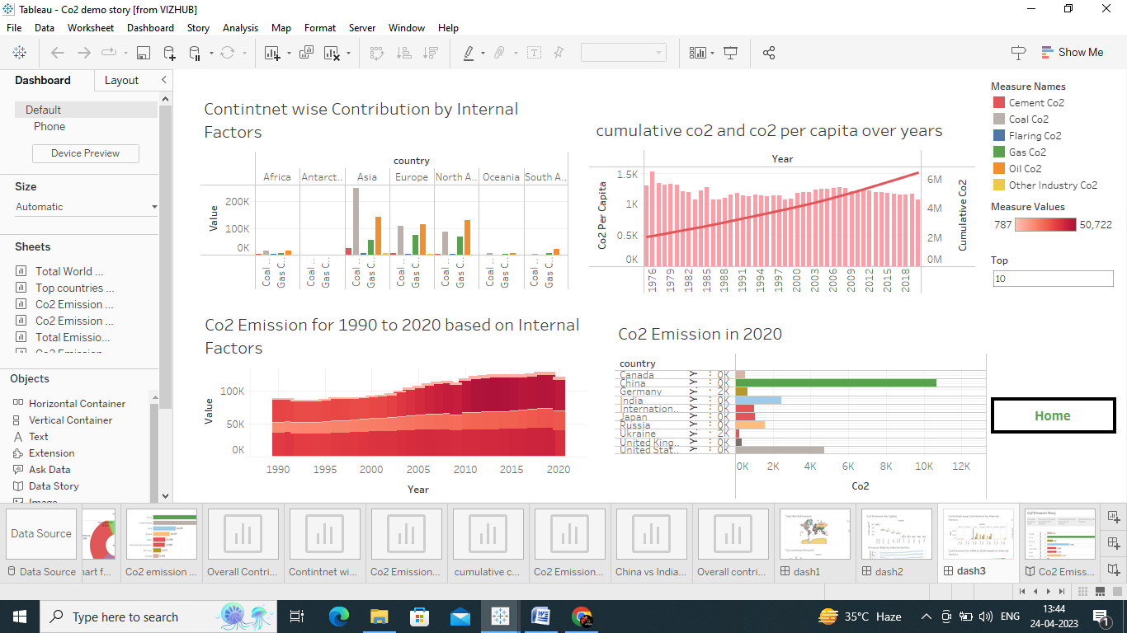

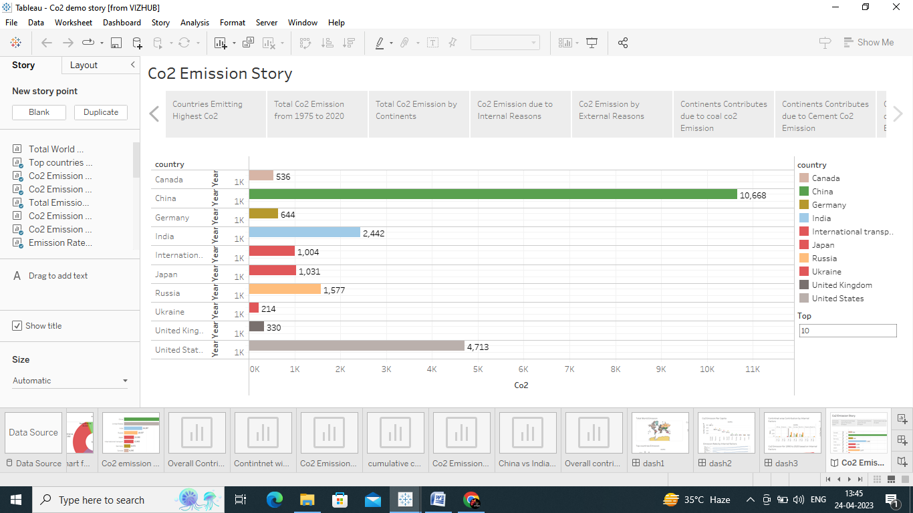

ADVANTAGES OF CO2
Green plants grow faster with more CO2. Many also become more drought- resistant because higher CO2 levels allow plants to use water more efficiently. More abundant vegetation from increased CO2 is already apparent.

DISADVANTAGES OF CO2
These may include headaches, dizziness, restlessness, a tingling or pins or needles feeling, difficulty breathing, sweating, tiredness, increased heart rate, elevated blood pressure, coma, asphyxia, and convulsions.

APPLICATIONS OF CO2
- The most obvious is the gas used for carbonating beverages, in particular beer, soft drinks, and wine...
- Carbon dioxide can also be used for de-caffeinating coffee.
- Thanks to its aforementioned cooling properties, CO2 keeps food products cold while they are being transported.

CONCLUSION
“The rising level of atmospheric CO2 could be the one global natural resource that is progressively increasing food production and total biological output, in a world of otherwise diminishing natural resources of land, water, energy, minerals, and fertilizer."

FUTURE SCOPE
CO2 Emissions in 2022 provides a complete picture of energy-related greenhouse gas emissions in 2022. The report finds that global growth in emissions was not as high as some had originally feared amid the disruptions caused by the global energy crisis. This latest release brings together the IEA’s latest analysis, combining the Agency’s estimates of CO2 emissions from all energy sources and industrial processes, as well as providing information on energy-related methane and nitrous oxide emissions.

